**CENWP-OD-B 27 June 2023**

**MEMORANDUM FOR THE RECORD**

**SUBJECT: 23BON038 MFR AFF Valve 15 Lamprey Mortalities**

On 27 June, Columbia River Inter-Tribal Fish Commission (CRITFC) Biologists notified Bonneville Project Biologists of four lamprey mortalities found on the valve 15 trash rack in the Adult Fish Facility (AFF). The fish were scanned for PIT tags, inspected, and returned to the river.

1. Species – Pacific Lamprey (*Entosphenus tridentatus)*
2. Origin – Unknown
3. Length – In descending order in the picture. 67.3 cm, 66 cm, cm, 62.2 cm, 73.6 cm.
4. Marks and tags – None
5. Marks and Injuries found on carcass – None
6. Cause and Time of Death – Unknown
7. Future and Preventative Measures – None

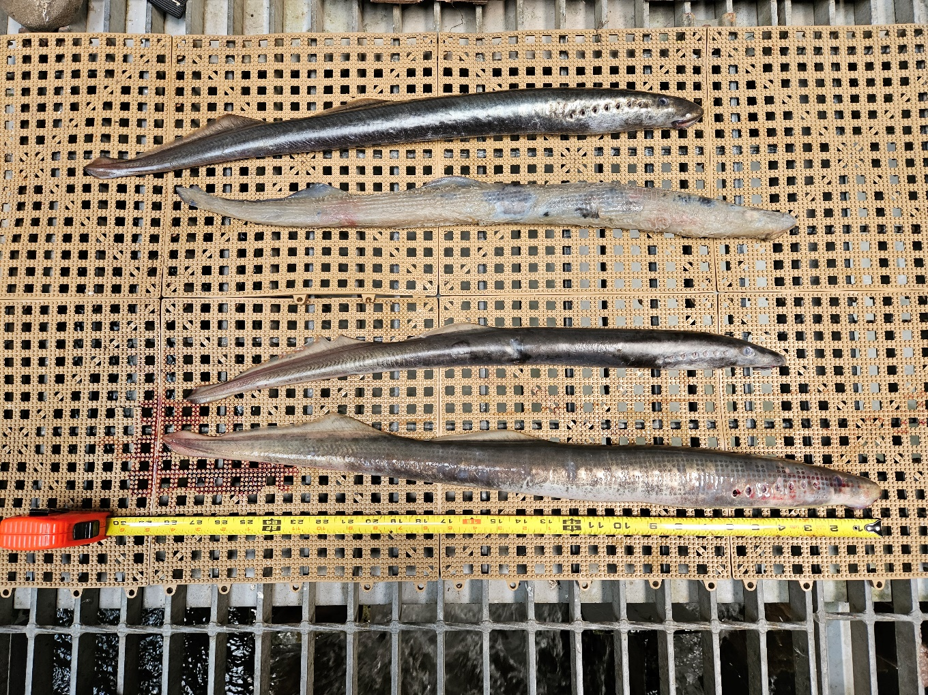

Sincerely,

Project Fisheries